Bahria University,

Karachi Campus

LAB EXPERIMENT NO.

**11**LIST OF TASKS

|  |  |
| --- | --- |
| TASK NO | OBJECTIVE |
| 1 | **Implement the Paging algorithm in C language.**  **.** |
| 2 | **Write a short note the Segmentation algorithm stating its main purpose and working mechanism.** |
| 3 | **Implement the Segmentation algorithm, write the C language program for it** |
|  |  |
|  |  |

Submitted On:

-June-2022

**Task No. 1: Implement the Paging algorithm in C language.**

**Solution:**

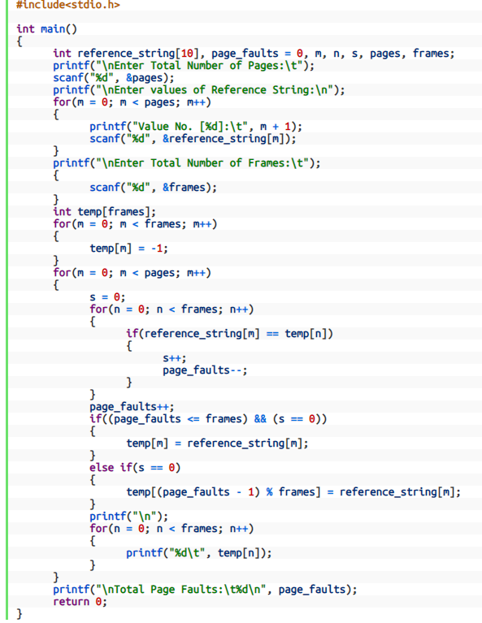

**Output**:

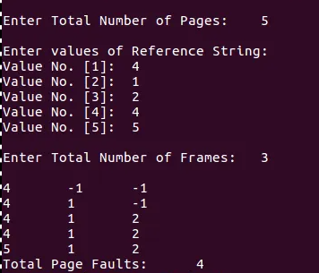

**Task No. 2: Write a short note the Segmentation algorithm stating its main purpose and working mechanism.**

**Solution:**

A process is divided into Segments. The chunks that a program is divided into which are not necessarily all of the same sizes are called segments. Segmentation gives user’s view of the process which paging does not give. Here the user’s view is mapped to physical memory.  
There are types of segmentation:

1. **Virtual memory segmentation –**  
   Each process is divided into a number of segments, not all of which are resident at any one point in time.
2. **Simple segmentation –**  
   Each process is divided into a number of segments, all of which are loaded into memory at run time, though not necessarily contiguously.